DATA 301 Notes October 7th, 2020

* Projects
  + Nothing due this week
  + Check out data.world
    - Has plethora of datasets
  + Kaggle—also has many datasets
  + We will be working primarily w/ text datasets
  + Proposal
  + Find an area that interests you
  + Doing it in groups encouraged
  + Try to use real datasets
* Lab 3 – posted a video on how to do it
  + Strings—sequences of characters that are surrounded by either single or double quotes
    - “”” useful for strings that contain quotes and/or line breaks
    - String indexing—want to pick out a particular string
      * Str(2) – get 3rd element (python starts counting at 0)
      * Substring – st[0:3]—if doing to “Hello”: Hel
      * [] – allow you to select certain values from an argument
      * {} – allows you to specify a particular string
      * 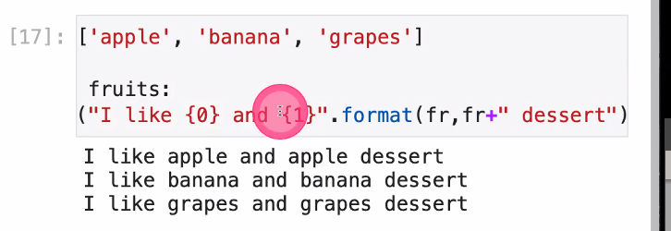
      * Date and time
        + Import
        + 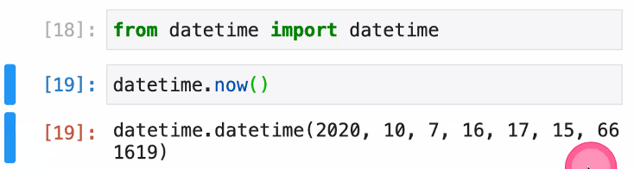’
        + Time.time() – imports time
        + Retrieving items from a list
        + Decisions—allow the progam to perform different actions based on conditions,

If condition: statement   
- only TRUE conditions will run

Else condition—can qualify if condition

Elif condition—short for “else if” – allows addition qualifier when else already utilised